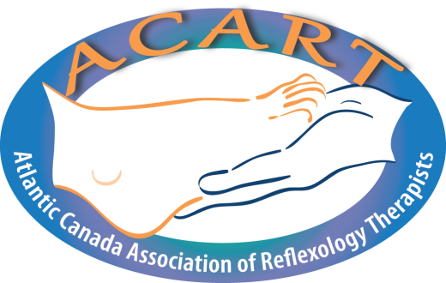The Atlantic Canada Association of Reflexology Therapists

CEU Reporting Form

Of the twenty (20) CEUs each member needs to accumulate per cycle, a minimum of ten (10) units must derive from Primary Activities. The balance of units may come from either Primary or Secondary Activities. Supporting documentation must be included. Please do not send originals in the event they are lost in the mail.

Name:__________________________________________________ RRT#:_______________
Cycle Start Date (Year):____________________Cycle End Date (Year):________

Date | Brief description | Primary or Secondary Activity | Number of Hours | Number of  CEUs

I certify I have obtained _________ CEUs from Primary Activities during this reporting cycle.
I certify I have obtained _________ CEUs from Secondary Activities during this reporting cycle.
I certify I have obtained a total of _______ CEUs during this reporting cycle.
Signature:_______________________________

